**Ethical Implications of Deepfake Technology**

Department of Electrical and Computer Engineering, Iowa State University

POL S 534, Legal and Ethical Issues in Cyber Security

Prof. Matt Behrens

February 19, 2024

**Abstract**

The tremendous advancements in artificial intelligence (AI) and deep learning have resulted in the development of advanced tools for altering multimedia materials, leading to the emergence of deepfakes. Although these technologies have valid uses, they have also been exploited for unethical intentions, including disseminating false information, political manipulation, and harassment. Deepfakes, which are convincingly altered videos, provide substantial ethical, moral, and legal dilemmas. The present research conducts a thorough literature analysis to examine different approaches employed in detecting deepfakes, emphasizing the significance of addressing the ethical ramifications associated with this technology. Given the potential for deepfakes to deceive and manipulate individuals, organizations, and societies, it is imperative to carefully examine the ethical and moral implications of their production and distribution. Furthermore, it is crucial to thoroughly analyze the legal structure concerning deepfakes, encompassing concerns for privacy, intellectual property rights, and defamation, to address and minimize any damage effectively. This study enhances the ongoing discussion on deepfake detection by examining the detection capabilities of various methodologies and technologies. It underscores the significance of ethical issues in creating and implementing deepfake detection tools. It is crucial to confront the ethical, moral, and legal difficulties presented by deepfakes to protect people and the community from the negative impacts of false information and manipulation.

**Introduction**

The advent of deepfake technology in the quickly changing realm of technology has introduced an entirely new era characterized by blending reality and fiction. Deepfakes, propelled by sophisticated artificial intelligence algorithms, facilitate the production of highly realistic modified content, including videos, audio recordings, and photographs, frequently impossible to differentiate from genuine media. Although technology shows potential for uses like entertainment and artistic expression, its ethical ramifications have generated heated discussions within academic, social, and technological circles.

The capacity to change visual and auditory input with such accuracy can give rise to several ethical considerations, encompassing:

1. **Misinformation and Fake News:**

A major ethical issue of deepfake technology is its susceptibility to misuse and fraud. Malicious entities can leverage deepfakes, which are highly realistic fabricated videos that are nearly impossible to differentiate from reality, to disseminate false information, manipulate public sentiment, and harm the standing of persons or entities. This prompts essential inquiries regarding the genuineness and reliability of digital media in a time where distinguishing truth from falsehood has become progressively complex.

1. **Privacy Violations:**

The ethical ramifications of deepfakes encompass matters about consent and privacy. The use of deepfake technology to overlay individuals' facial features onto explicit or compromising material without explicit authorization gives rise to significant apprehensions over consent, self-governance, and the entitlement to claim authority over one's visual representation. The illicit production and distribution of deepfakes can result in substantial psychological and emotional consequences for the subjects portrayed, including damage to their reputation, harassment, and potential extortion.

1. **Social and Political Manipulation**:

The ethical implications of deepfake technology coincide with broader societal issues, including the degradation of media credibility, the spread of disinformation, and the risk of political manipulation. With the growing complexity and availability of deepfakes, politicians, engineers, and ethicists are tasked with creating frameworks and rules to tackle the ethical challenges presented by this swiftly advancing technology.

1. **Manipulation of Reality:**

Given the ethical issues involved, it is crucial to thoroughly analyze the consequences of deepfake technology and contemplate the ethical standards that should govern its creation, implementation, and oversight. Through deliberate and conscientious discussions and moral contemplation, we may successfully negotiate the complex ethical challenges posed by deepfakes and work towards utilizing this technology in a responsible manner for the improvement of society.

**The basic approach behind deepfakes**

1. **Origins of the Deepfake Technology:**

At the 2016 Conference on Computer Vision and Pattern Recognition, Justus Thies and his colleagues presented a groundbreaking study that established the basis for the current understanding of deepfake technology. This pioneering research introduced a technique that radically transformed the dynamics of video manipulation. Their novel methodology allowed a designated individual, referred to as the 'source,' to exert influence over the facial expressions of another individual, referred to as the 'target,' in a video. The control was attained through an intricate procedure of re-rendering the desired video, resulting in a final product that was remarkably authentic and visually persuasive. In essence, the invention enabled the smooth replacement of facial expressions in videos, paving the way for the following development and ethical implications of deepfake technology.

1. **Creation of the term Deepfake:**

The phrase "deep fake" originated in the online domain, attributed to a Reddit user entitled 'deepfakes' who drew status in 2017 by overlaying the faces of renowned actresses onto pornographic material. This application highlighted the possible abuse of deepfake technology. The following development of the user-friendly FakeApp in 2018 significantly expanded access, making deepfake capabilities easily accessible to many people.

1. **Comparison between Face2Face and Deepfake:**

A significant differentiation is drawn between previous technologies, such as Face2Face, which mainly concentrated on modifying facial movements, and the subsequent deep fakes, which specifically targeted the manipulation of facial texture while maintaining the original expressions. Both methods required the initial recognition of facial characteristics.

1. **Early Architecture and Technique:**

Early deepfake projects were influenced by two fundamental frameworks: Generative Adversarial Networks (GANs) and Autoencoders (AEs). GANs involve utilizing two neural networks, namely the generator and discriminator, which are competitively placed against each other. The generator uses the acquired information of the neural network to generate an original image as its output. The discriminator is responsible for distinguishing between legitimate and false images.

Both components maintain a continuous interaction. The generator can generate images that trick the discriminator into classifying them as authentic. The discriminator, conversely, gains the ability to avoid being deceived. The higher the discriminative ability, the more challenging it becomes for the generator to provide authentic images, resulting in a more effective performance. Autoencoders (AEs), on the other hand, utilize an encoder to compress images into concise vectors and a decoder to restore the initial material. Nevertheless, these preliminary endeavors were characterized by a high level of computing complexity and posed difficulties regarding reproducibility.

1. **Evolution of Deepfake Technology:**

The text also describes the development of deepfake technology, with recent scholarly contributions suggesting a shift towards greater efficiency in terms of data and computing needs. As evidenced by their research, Zakharov and his colleagues extended the capabilities of Generative Adversarial Networks (GANs) and Autoencoders (AEs). They showcased their ability to regenerate static images and convincingly modify their appearance. Significantly, these technologies expanded to include speech modulation and visual manipulation.

1. **Synergy between Academic Research and Mass Market Adoption:**

Notably, the sentence emphasizes the interactive relationship between scholarly research and the extensive utilization of GANs technology in the mainstream market. It highlights the shift from complex and resource-demanding procedures to more efficient and user-friendly methods. This evolution establishes the foundation for further investigation into the ethical problems and regulatory obstacles linked to the increasing prevalence of deepfake technology.

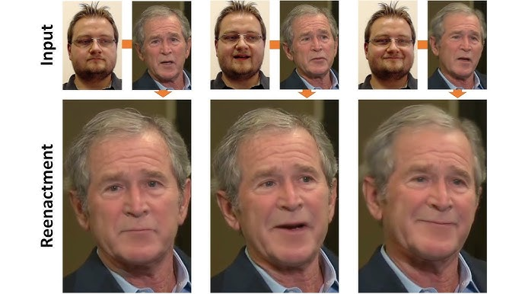

**Figure 1.** Illustration of Face2Face method

**Unmasking Deception: A Comprehensive Analysis of Deepfake Incidents and Their Societal Implications**

**Case 1: Deep fake in Political Campaigns:**

1. **Misleading Political Speeches:**

**Overview:** Deepfake technology facilitates the production of genuine videos that can alter individuals' facial expressions and speech.

**Impact:** Political figures can be depicted delivering speeches or statements that they never actually made, which can impact public opinion and undermine the genuineness of political discussions.

1. **Fabrication of Compromising Scenarios:**

**Overview:** Deepfakes have the potential to generate manipulated information that portrays political candidates engaged in compromising or inappropriate scenarios.

**Impact:** Regardless of its fictional nature, such content has the potential to harm a candidate's reputation and trustworthiness, resulting in public suspicion.

1. **Voice Cloning for Audio Manipulation:**

**Overview:** Deepfake technology encompasses voice cloning, enabling a recreation of a candidate's voice to generate appealing audio communications.

**Impact:** This type of manipulation challenges voters to discern accurate and manipulative information, which could impact their decision-making process.

1. **Spread of Misinformation:**

**Overview:** Deepfakes enhance the spreading of false information by generating highly authentic but entirely created content.

**Impact:** The spreading of false narratives, speeches, or statements during political campaigns can sway public opinion, resulting in the spread of misinformation and the manipulation of voters.

1. **Erosion of Trust:**

**Overview:** The widespread existence of deepfake content in political campaigns could lead to a more extensive breakdown of confidence in political communication.

**Impact:** With the rise of deepfakes, the distinction between reality and manipulation is becoming less clear, making people more doubtful about the genuineness of media information concerning political personalities.

1. **Cybersecurity Threats:**

**Overview:** Using deepfakes in political campaigns presents cybersecurity risks since carefully transmitted material might lead to disbelief and potentially jeopardize the security of a nation.

**Impact:** Deepfakes can be utilized as components of broader cyber-espionage strategies or disinformation operations, posing supplementary obstacles to safeguarding the integrity of democratic processes.

1. **Policy and Regulatory Responses:**

**Overview:** Authorities and regulatory entities need help to develop policies and regulations to effectively deal with the threats posed by deepfake technology in political settings.

**Impact:** The discussions mostly revolve around the integrity of content, the accountability of online platforms, and the potential legal ramifications associated with the production and distribution of deepfakes within the political sphere.

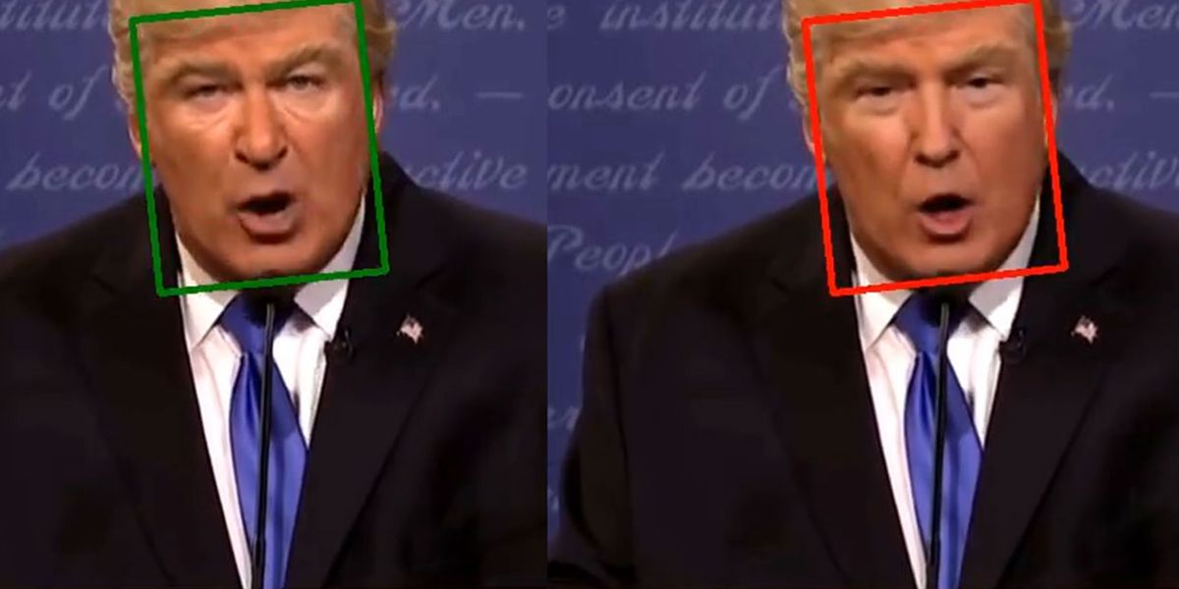

**Figure 2.** Deepfake in Political Campaigns.

**Instance**:

The advent of deepfake technology presents a significant and complex problem in current communication. The decisive moment unfolded when BuzzFeed released a deepfake video showcasing former US President Obama, illustrating the simplicity with which manipulated content may be generated. This technology has extensive ramifications, including the potential to harm individuals' reputations, disseminate misinformation, and influence political processes. From an individual's perspective, the risk resides in forming a parallel existence, wherein public people can be manipulated to say or perform actions they never actually did, damaging the ancient concept that 'seeing is believing.'

The reaction to deepfakes is complex, as possible legal and regulatory actions are subjected to constitutional examination. In the current political landscape, characterized by no regard for truth, the need for efficient communication takes priority above moral or factual aspects. From an individual's standpoint, it is challenging to quantify the influence of deepfakes, as their dissemination on social media may surpass that of traditional political campaigns. This gives rise to concerns over manipulating public perception at a time when distinguishing truth from lie becomes progressively more difficult. The academic discussion on the ethical considerations of deepfake technology emphasizes the need for a sophisticated comprehension of its consequences. It urges researchers to investigate and develop practical solutions and regulatory structures to navigate this ever-changing domain responsibly.

**Review**:

When considering the influence of deepfake technology on political campaigns, focusing on the individual's perspective emphasizes the potential for empowerment and the ability to adapt and recover. Instead of passively receiving information, individuals can actively enhance their media literacy and digital skills. Education activities and awareness campaigns enable citizens to differentiate between genuine information and misleading stuff. Technological methods for verification and fact-checking are becoming increasingly important in this situation, as they allow individuals to verify the authenticity of media information independently. By adopting and utilizing such tools, individuals enhance their ability to critically evaluate information, contributing to a more informed and discriminating electorate. Furthermore, it is essential to cultivate emotional resilience, which necessitates a change in thinking that enables individuals to approach political material with reasonable doubt. This perspective emphasizes the proactive role that individuals can have in their intake of media. A comprehensive approach to addressing the issues posed by deepfake technology involves integrating education, technological involvement, and emotional resilience. By adopting these strategies, individuals protect themselves from the effects of deepfakes but also actively contribute to advancing a better-informed, discriminating, and empowered voting population.

**Case 2: Commercial uses of Deep fake:**

Deepfake technology has practical uses beyond entertainment and can positively affect several industries. An instance is the utilization of deepfakes by organizations such as CereProc, which exploits this technology to generate voices for persons who have experienced the loss of their loved ones due to diseases. Voice replication technologies, enabled by deepfakes, present a distinctive chance for individuals to participate in virtual dialogues with their deceased relationships or loved ones, offering a means of emotional comfort and connection.

Moreover, the utilization of Generative Adversarial Networks (GAN) technology in video creation holds the capacity to transform the sector. Conventional video production relies on tangible procedures like cameras, studios, and performers, which inevitably limits its ability to be scaled up. Utilizing GAN technologies enables the production of synthetic videos at a reduced expense, resulting in substantial time and resource savings. A concrete instance is the deepfake film featuring David Beckham, which was produced to endorse the Malaria Must Die campaign. Beckham's facial features and vocal expressions were altered to allow him to "speak" in nine other languages, demonstrating the varied and innovative uses of deepfake technology for social purposes.

With the continuous advancement of GAN technologies, the commercial environment is on the verge of a significant transformation, bringing out innovative business models and unique modes of communication. There is a possibility that 'deep fake data silos' may be formed on the internet, which would have control over the production and distribution of deepfakes. Although there are ethical benefits to using deepfakes for commercial purposes, these technologies must be utilized within the boundaries of the law.

The paper highlights the importance of gaining agreement from the right holders before developing deepfake content, considering legal constraints. When disputes occur over the rightful ownership of content produced using GAN technology, well-established legal principles, and theories in contract or tort law might be utilized to facilitate a resolution. The current regulations on initial ownership or the work-made-for-hire doctrine can be applied where there is a need for clarification regarding the ownership of newly created content generated using deepfake technology. In general, the practical applications of deepfakes offer potential for beneficial effects on society as long as they comply with legal and ethical guidelines.

**Review:**

To thoroughly explore the effects of deepfake technology in commercial contexts, it is necessary to analyze various important aspects carefully. It is essential to explore the psychological impact on users when considering the emotional relief that deepfakes may offer in virtual interactions with deceased loved ones. Moreover, the simplicity and cost-efficiency of deepfake-generated content give rise to questions over its influence on the genuineness of artistic expression, leading to contemplation on the changing essence of creativity. An analysis of deepfakes in educational institutions uncovers possible threats to the integrity of information, underscoring the importance of implementing measures that mitigate the spread of false or misleading information. It is crucial to prioritize consumer awareness and consent in commercial deepfake applications to protect ethical considerations and uphold individual agency. Stringent laws are essential to safeguardagainst unlawful utilization of data to address the privacy problems linked to **'**deep false data silos.' Considering more significant cultural and societal consequences is vital, anticipating alterations in values and norms as deepfake technology becomes more common. Ultimately, the potential benefits of enabling persons through digital avatars emphasize the significance of investigating applications that promote inclusiveness and customized online experiences.

**Case 3: Creative deep fakes:**

Creative deep fakes demonstrate the artistic and innovative utilization of deepfake technology to produce content beyond conventional applications. These creations frequently include manipulating visual and audio elements to generate imaginative and fascinating results.

**Artistic Expression:** Creative deep fakes empower individuals to express themselves artistically by blending faces, voices, or scenarios in novel and unconventional ways. The artistic expression can include:

* Placing familiar faces in unexpected contexts.
* Reimagining iconic scenes.
* Even generating entirely fictional scenarios.

**Scientific Exploration:** Beyond artistic endeavors, creative deep fakes have found applications in scientific exploration and experimentation. Researchers and students may use the technology to simulate scenarios, conduct virtual experiments, or explore hypothetical situations in a visually immersive manner.

**Educational Purposes:** Creative deep fakes can serve educational objectives by offering engaging and interactive learning experiences. Students and educators may use the technology to recreate historical events, simulate scientific experiments, or bring to life theoretical concepts in a more relatable manner.

**Political Debates:** Some deep fakes are created to engage in political debates or commentaries. They can be employed to visualize hypothetical scenarios, portray alternative political narratives, or satirize political figures. This application raises questions about the ethical use of deep fakes in influencing public opinion.

**Instance:**

Face-swapping technology, particularly deep fakes, is no longer primarily linked to sexual content. The online community has channeled its creative abilities by incorporating Nicolas Cage's face into famous moments from well-known movies. This movement emphasizes the wider range of uses of deep fakes, including artistic expression and scientific research, especially in educational environments.

Although deep fakes might stimulate creativity and free speech, they can pose concerns, such as the risk of bullying, especially among schoolchildren. The evolving technology's impact on social dynamics and ethical considerations is concerning.

 Legally, deep fakes pose a complex situation. In addition to privacy issues, they involve essential legal principles like contract, tort, and property law. Intellectual property concerns, especially in copyright law, are highlighted. Legal conflicts may include:

* Authorship.
* Infringement of third-party rights.
* The interpretation of fair use rules.

Creators may try to claim protection through exemptions such as parody. Still, the legal results depend on elements such as the work's transformative quality, the original content's attributes, the amount used, and the possible effect on the market.

As technology progresses, the legal system must evolve to deal with the complex relationship between creation, expression, and intellectual property rights in deep fakes. This technology's changing nature requires a strategic and adaptable legal approach to address its complex consequences.

**Review:**

Individuals must acknowledge creative deep fakes' cultural and social impact and understand how they can influence societal standards. It is essential to comprehend the psychological impact on persons exposed to modified content to evaluate the more significant effects on mental health. Increasing user awareness and education can help individuals identify and analyze deep fakes more effectively, thus improving digital literacy. Promoting ethical content development and developing collaborative platforms for responsible use are essential factors to consider. Individuals can also support sensible rules that balance creative freedom and societal protection.

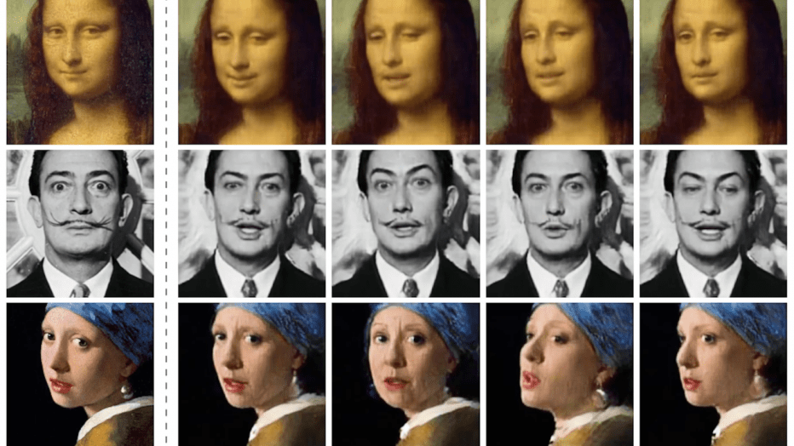

**Figure 3.** Creative Deep Fakes.

**Methodology**

1. **Ethical Framework Analysis:**

An extensive examination of ethical frameworks of deepfake technology highlights the utmost significance of values such as privacy, consent, autonomy, and harm. The issue of privacy becomes obvious when deepfake content is created and shared without permission, as it involves the unlawful use of someone's likeness. This raises concerns about safeguarding personal information and the right to control one's image. Consent, a fundamental ethical principle, is of utmost importance in guaranteeing that individuals are fully informed about and provide their agreement to the utilization of their data for deep fake applications. Autonomy, closely linked to consent, highlights individuals' need to exert authority over their digital portrayals and the narratives generated by deepfake technology. The ethical principle of harm is complex, including the potential damage to individuals' reputations and the wider societal consequences of misinformation and manipulation. Examining these moral concepts within deepfake production highlights the need for explicit laws to protect privacy and autonomy, guarantee informed consent, and reduce potential harm. Ethical considerations should direct the creation of comprehensive regulatory frameworks that govern the responsible utilization of deepfake technology in many areas.

**Individual Analysis:**

When developing ethical frameworks for deepfake technology, it is essential to consider the psychological effects on persons, mainly focusing on the emotional suffering that can result from digital modifications. Digital identity is necessary for safeguarding one's integrity and values. Furthermore, it is crucial to prioritize the vulnerability of marginalized groups and ensure that ethical considerations consider the unequal impact on specific populations. Advocating for digital literacy and education enables users to navigate deepfake technology responsibly. Legal obligations, community norms, technological accessibility, and cultural sensitivity should be essential for ethical frameworks to offer a thorough and person-centered approach.

1. **Case Study Analysis**:

Another intriguing real-life example is the fraudulent imitation of a Chief Executive Officer using deepfake technology. In one case, fraudsters employed deepfake technology to accurately imitate the CEO's speech and behavior, resulting in a successful endeavor to carry out illegal money transfers within the organization. The deepfake was utilized to mislead staff into believing they were adhering to authentic orders from the CEO. This case presents ethical considerations regarding the potential financial detriment of deepfake impersonation and the broader ramifications for business trust and internal security. This highlights the importance of creating ethical rules and adopting strong cybersecurity safeguards to prevent the criminal misuse of deepfake technology for financial fraud and corporate sabotage.

**Individual Analysis:**

The deceptive replication of a Chief Executive Officer (CEO) through deepfake technology is a striking real-world illustration with substantial ethical ramifications. In this instance, attackers leveraged the capabilities of deepfake technology to accurately imitate the speech and conduct of the CEO, resulting in the successful and unlawful movement of funds throughout the firm. The ethical implications are significant, including the possible financial detriment caused by deepfake impersonation and the more significant effects on business trust and internal security. This incident highlights the critical necessity for ethical protocols and strong cybersecurity safeguards to prevent the malicious misuse of deepfake technology for financial deception and business sabotage. In addition to the immediate economic impact, such occurrences prompt inquiries into the broader cultural and political ramifications of deepfake usage. This underscores the crucial need to tackle these ethical issues to maintain trust in both business and public spheres.

**Strengths covered:**

1. **Comprehensive Analysis**: The paper provides a comprehensive analysis of the ethical implications of deepfake technology by categorizing deepfakes into four main categories and examining each category through the lens of legal and ethical considerations.
2. **Real-World Examples**: The authors discuss real-world examples of deep fakes, such as deep fake pornography and deep fakes in political campaigns, to illustrate the technology's ethical challenges and unintended consequences.
3. **Regulatory Perspective**: The paper offers a regulatory and legal perspective on deepfake technology, discussing the role of online content dissemination platforms and governments in addressing deepfakes.
4. **Ethical Considerations**: The authors address ethical aspects of deep fakes, including the initial fear and concerns associated with the technology and the potential beneficial outcomes of reducing transaction costs and facilitating new forms of creativity.

**Weaknesses covered:**

1. **Limited Discussion on Detection Technology**: While the paper raises whether deep fake detection technology could help fight socially perilous deep fakes, it does not delve deeply into the effectiveness or challenges of such detection technologies.
2. **Lack of In-Depth Regulatory Analysis**: While the paper touches on regulatory aspects of deepfake technology, it may need a detailed analysis of existing laws and regulations specific to deepfakes in different jurisdictions, which could provide more insights into the regulatory challenges.
3. **Limited Stakeholder Perspectives**: The paper may not extensively explore the perspectives of various stakeholders involved in the deepfake ecosystem, such as creators, platforms, and affected individuals, which could offer a more nuanced understanding of the ethical implications.
4. **Need for Comparative Analysis**: The paper could benefit from a comparative analysis of the ethical implications of deepfake technology with other forms of digital manipulation, providing a broader context for understanding the unique challenges deepfakes pose.

**Conclusion**

The literature review on the ethical implications of deepfake technology concludes by emphasizing the multifaceted analysis presented in the reviewed works. It acknowledges the structured categorization of deepfakes, real-world examples that illustrate ethical dilemmas, regulatory insights, and a nuanced exploration of ethical considerations. Comprehensive categorization is a valuable framework for understanding the ethical challenges across different deepfake applications. Real-world examples highlight tangible ethical dilemmas, while the regulatory perspective suggests potential measures for mitigation. The review maintains a balanced perspective, recognizing both the potential harm and the creative possibilities of deepfake technology. However, it also highlights potential limitations in categorizations, for example, selectivity and the need for a more comprehensive regulatory exploration. The urgency of addressing deepfake technology's ethical implications is underscored, urging a holistic and informed approach for future research, policy development, and ethical guidelines. Synthesis of perspectives and examples establishes a groundwork forresponsibly navigating the evolving landscapeofsynthetic media. Continuous scholarly engagement is advocated to address emerging ethical challenges in deepfake technology proactively.

**References**:

* 1. Rana, M. S., Nobi, M. N., Murali, B., & Sung, A. H. (2022). Deepfake Detection: A Systematic Literature Review. *IEEE Access*, *10*, 25494–25513. <https://doi.org/10.1109/access.2022.3154404>
  2. Meškys, E., Liaudanskas, A., Kalpokienė, J., & Jurčys, P. (2020). Regulating deep fakes: legal and ethical considerations. *Journal of Intellectual Property Law & Practice*, *15*(1), 24–31. <https://doi.org/10.1093/jiplp/jpz167>
  3. Van Der Sloot, B., & Wagensveld, Y. (2022). Deepfakes: regulatory challenges for the synthetic society. *Computer Law & Security Review*, *46*, 105716. <https://doi.org/10.1016/j.clsr.2022.105716>
  4. Kidd, J., & McAvoy, E. N. (2023). Deep Nostalgia: Remediated memory, algorithmic nostalgia and technological ambivalence. *Convergence*, *29*(3), 620–640. <https://doi.org/10.1177/13548565221149839>
  5. The new virtuality: a creative website on blurred boundaries between the real and unreal. (2021). *The Journal of Media Art Study and Theory*. <https://doi.org/10.59547/26911566.4.1.06>
  6. Wach, K., Duong, C. D., Ejdys, J., Kazlauskaitė, R., Korzyński, P., Mazurek, G., Paliszkiewicz, J., & Ziemba, E. (2023b). The dark side of generative artificial intelligence: A critical analysis of controversies and risks of ChatGPT. *Entrepreneurial Business and Economics Review*, *11*(2), 7–30. <https://doi.org/10.15678/eber.2023.110201>
  7. Hancock, J. T., & Bailenson, J. N. (2021). The social impact of Deepfakes. *Cyberpsychology, Behavior, and Social Networking*, *24*(3), 149–152. <https://doi.org/10.1089/cyber.2021.29208.jth>
  8. Passos, L. A., Passos, L. A., Costa, K. a. P., Júnior, L. a. S., Rodrigues, D., Del Ser, J., Camacho, D., & Papa, J. P. (2023). A review of deep learning-based approaches for deepfake content detection. *Authorea (Authorea)*. <https://doi.org/10.22541/au.169735672.27713914/v1>
  9. Dagar, D., & Vishwakarma, D. K. (2022). A literature review and perspectives in deepfakes: generation, detection, and applications. *International Journal of Multimedia Information Retrieval*, *11*(3), 219–289. <https://doi.org/10.1007/s13735-022-00241-w>
  10. Stroebel, L., Llewellyn, M., Hartley, T., Ip, T. S., & Ahmed, M. (2023). A systematic literature review on the effectiveness of deepfake detection techniques. *Journal of Cyber Security Technology*, *7*(2), 83–113. <https://doi.org/10.1080/23742917.2023.2192888>
  11. Wagner, T. L., & Blewer, A. (2019). “The word real is no longer real”: Deepfakes, gender, and the challenges of AI-Altered video. *Open Information Science*, *3*(1), 32–46. <https://doi.org/10.1515/opis-2019-0003>
  12. Tolosana, R., Vera-Rodríguez, R., Fiérrez, J., Morales, A., & Ortega-García, J. (2020). Deepfakes and beyond: A Survey of face manipulation and fake detection. *Information Fusion*, *64*, 131–148. <https://doi.org/10.1016/j.inffus.2020.06.014>
  13. Korshunov, P., & Marcel, S. (2018). DeepFakes: a New Threat to Face Recognition? Assessment and Detection. *arXiv (Cornell University)*. Korshunov, P., & Marcel, S. (2018). DeepFakes: a New Threat to Face Recognition? Assessment and Detection. *arXiv (Cornell University).*
  14. Seow, J., Lim, M., Phan, R. C., & Liu, J. K. (2022). A comprehensive overview of Deepfake: Generation, detection, datasets, and opportunities. *Neurocomputing*, *513*, 351–371. <https://doi.org/10.1016/j.neucom.2022.09.135>
  15. Waseem, S., Abu-Bakar, S. a. R., Ahmed, B. A., Omar, Z., Eisa, T. a. E., & Dalam, M. E. E. (2023). DeepFake on Face and Expression Swap: a review. *IEEE Access*, *11*, 117865–117906. https://doi.org/10.1109/access.2023.3324403